**History Policy**

St Laurence in Thanet Church of England Junior Academy

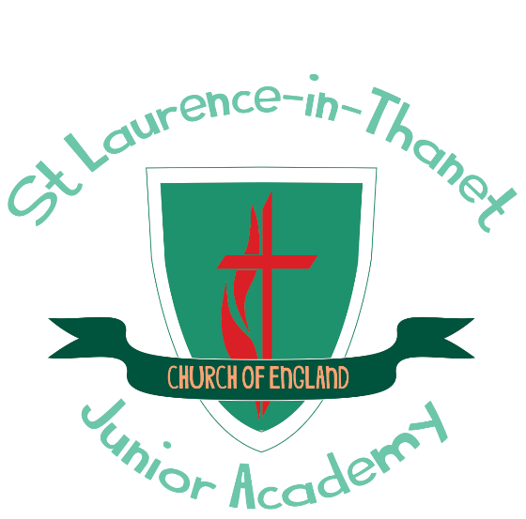

**Our school offers a supportive, inclusive, nurturing and inspiring learning environment where each member is known by God, loved and empowered to reach their full potential. Children are encouraged through an aspirational and engaging curriculum to develop their knowledge, skills and character so that they can truly flourish, both now and into the future.**

This set of values is reflected in all our policies.

Joy Hope Forgiveness Love Resilience

|  |  |  |
| --- | --- | --- |
| **Approved by:** | J Spencer | **Date:** April 2025 |
| **Last reviewed on:** | April 2025 | |
| **Next review due by:** | April 2027 | |

**Introduction**

This policy outlines the purpose, nature and management of the history taught and learnt in our school. It has been adopted by the staff of St Laurence C of E Junior Academy. This policy outlines the guiding principles by which this school will implement history.

**Rationale for History teaching**

The aim of teaching History is to stimulate the children’s interest and understanding about the life of people who lived in the past. We teach children a sense of chronology, and, through this, they develop a sense of identity, and a cultural understanding based on their historical heritage. We also teach the children to investigate these past events and, by so doing, develop the skills of enquiry, analysis, interpretation and problem solving.

**Aims for the teaching of History at St Laurence C of E Junior Academy**

At St Laurence our intention is to provide quality teaching and learning of history. We aim:

* To promote an interest in the past and an understanding of events over time.
* To develop an ability to investigate and interpret past events.
* To learn to study historical evidence and to ask and answer questions.
* To develop the ability to communicate historical knowledge and understanding.
* To encourage children to understand people, their beliefs, thoughts and values.
* To acquire a sense of their cultural heritage.

We also seek to encourage children to develop the following skills:

* Interpretation and investigation.
* Chronological understanding.
* Knowledge and understanding of events.
* Knowledge of people and changes in the past.
* Presenting, organising and communicating information and ideas.

**Teaching and learning**

We give the children the opportunity to visit sites of historical significance and place an emphasis on examining historical artefacts and primary sources. We encourage visitors to come into the school and talk about their experiences of events in the past. We recognise that in all classes, children have a wide range of ability in history, and we seek to provide suitable learning opportunities for all children by matching the challenge of the task to the ability of the child.

**The role of the History subject leader is:**

* Taking the lead in the development, evaluation and amendment of schemes of work
* Acting as a consultant to colleagues
* Monitoring and evaluating children’ work, children’ views about the subject and planning
* Auditing and ordering resources when needed
* Keeping up to date with developments in history and disseminating information to the rest of the teaching staff. Attending relevant CPD and prompting others about relevant training
* Leading staff meetings as appropriate

**History curriculum planning**

History is a foundation subject in the National Curriculum. We use an enquiry based learning process**,** supported by resources developed by the Historical Association as a basis for our curriculum planning. There is a strong element of local heritage that runs through the curriculum, something recognised by the school being awarded the Heritage Schools programme award by Historic England. We use the national scheme of work as the basis for our long and medium-term plans, which the subject leader reviews regularly. Each lesson will have an LQ (Learning question) that feeds into the over arcing EQ (Enquiry question) along with a Success Criteria which lists specific objectives and expected outcomes for the lesson. Children of all abilities have the opportunity to develop their skills and knowledge in each unit and, through planned progression built into the scheme of work, we offer them an increasing challenge as they move up the school.

**Key Stage 2**

The National Curriculum Programme of Study at Key Stage 2 should continue to allow children to develop a chronologically secure knowledge and understanding of British, local and world history, establishing clear narratives within and across the periods they study. They should note connections, contrasts and trends over time and develop the appropriate use of historical terms. They should regularly address and sometimes devise historically valid questions about change, cause, similarity and difference, and significance. Children should construct informed responses that involve thoughtful selection and organisation of relevant historical information. They should understand how our knowledge of the past is constructed from a range of sources. In planning to ensure the progression, teachers should combine overview and depth studies to help children understand both the long arc of development and the complexity of specific aspects of the content.

**Cross Curricular links**

**Literacy** - History contributes significantly to the teaching of Literacy in our school by actively promoting the skills of reading, writing, speaking and listening. Some of the texts that are used in Literacy lessons are historical in nature. Children develop oracy through discussing historical questions or presenting their findings to the rest of the class. They develop their writing ability by composing reports and letters and through using writing frames.

**Numeracy** - Children learn to use numbers when developing a sense of chronology through doing activities such as time-lines. Children learn to interpret information presented in graphical or diagrammatic form.

**Computing** - Children use computing in history to enhance their skills in data handling and in presenting written work, and they research information using the Internet, including the reliability of information and sources.

**PSHE** – Children develop self-confidence by having opportunities to explain their views on a number of social questions, such as how society should respond to poverty and homelessness. They learn how society is made up of people from different cultures, and they start to develop tolerance and respect for others. We also provide children with the opportunity to discuss moral questions, or what is right and wrong, when studying topics such as the treatment of children in Ancient Greece.

**Assessment**

Formative assessment is use to monitor student learning and provide ongoing feedback to the children during the unit of work. At the end of a unit, summative assessment is to evaluate learning by completing the assessment spreadsheet based on the progression of skills.

**Marking**

Feedback to children should be provided on their attainment against the objectives of history. Children are encouraged to improve their own learning performance through the school feedback policy.

**Monitoring and review**

The coordination and planning of the history curriculum are the responsibility of the subject leader. The subject leader is responsible for evaluating the strengths and weaknesses in history and indicating areas for further improvement on the following action plan. The subject leader will also monitor history books and schemes of work to ensure that the Programmes of Study are being effectively taught and match the needs and abilities of the children

**Inclusion and differentiation**

At our school, we teach history to all children, whatever their ability and individual needs. History forms part of the school curriculum policy to provide a broad and balanced education to all children. Through our history teaching, we provide learning opportunities that enable all children to make good progress. We strive hard to meet the needs of those children with special educational needs, those with disabilities, those with special gifts and talents, and those learning English as an additional language, and we take all reasonable steps to achieve this. We use a range of strategies to support and challenge children.

**Resources**

There are sufficient resources for all history teaching units in the school. We keep these resources in a central store, where there is a box of equipment for each unit of work. The library contains a good supply of topic books and access to the Internet to support the children’s individual research